|  |  |  |
| --- | --- | --- |
| **LAB 321 Assignment** | **Type:** | **Long Assignment** |
| **Code:** | **J3.L.P0008** |
| **LOC:** | **300** |
| **Slot(s):** | **10** |

**Title:** Simple attendance

**Background**

Simple attendances like our uniap system, which will help lecturer manage and do the attendances.

**Program Specifications**

Program a simple attendance system, detail functions of this website is described below

**Features:**

This website contains 04 (four) main functions

* Function 1: Login page ( see figure 01)
* Function 2: Take attendance page (see figure 02)
* Function 3: View attendance page (see figure 03)
* Function 4: Update attendance page (see figure 04)

Note: All data must be load from database, not hard code.

***Expectation of User interface:***

Pic 01: Login Page ( TOP)

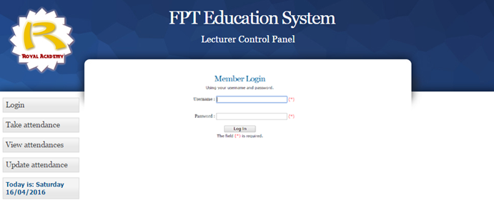

PIC 02: Take attendance Page

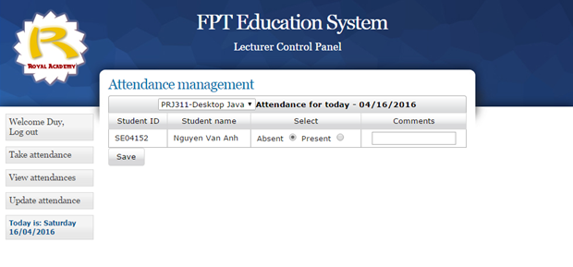

Pic 03: View attendance Page

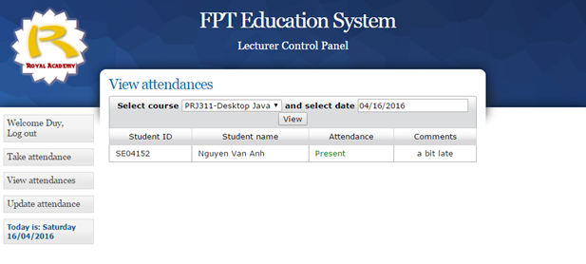

Pic 04: Update attendance Page

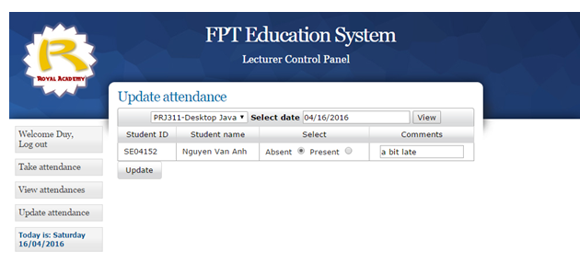

**Guidelines**

* Step 1 : Create prototype
* Step 2 : Design database base on created prototype
* Step 3 : Code & Test